Lab 2

1-restructure your code to use variables
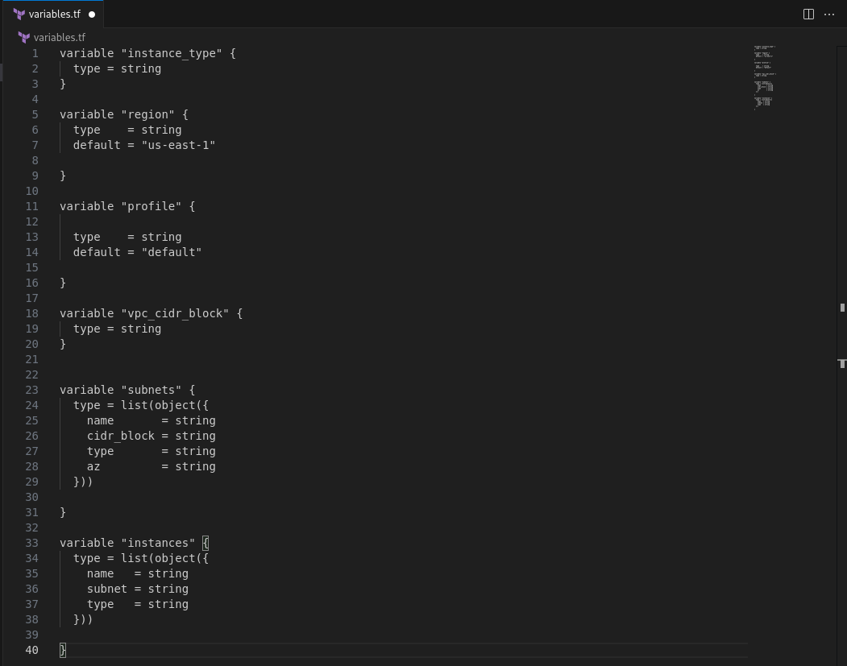
2-create all subnets with single resource using for_each
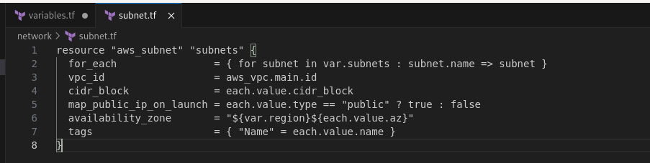

3-make condition on subnet resource based on type (public or private) to control
map_public_ip_on_launch
4-create all ec2s with single resource using count

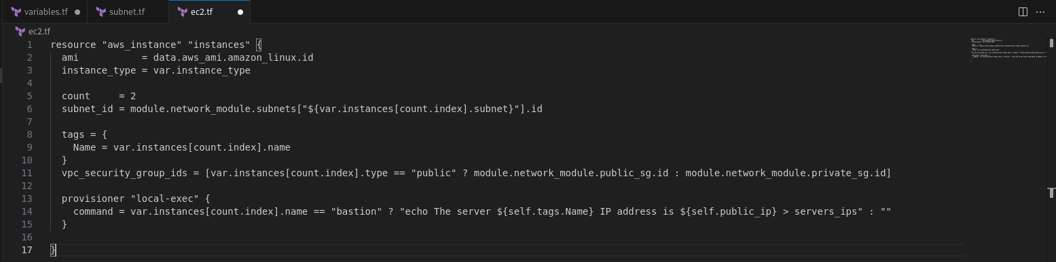
5-create two workspaces dev and prod
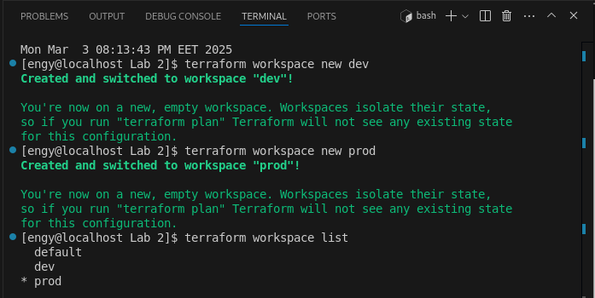

6-create two variable definition files(.tfvars) for the two environments
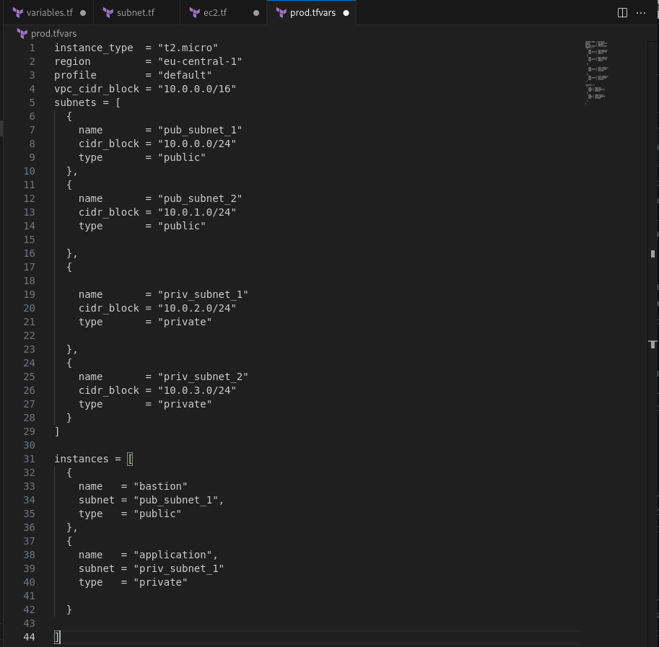

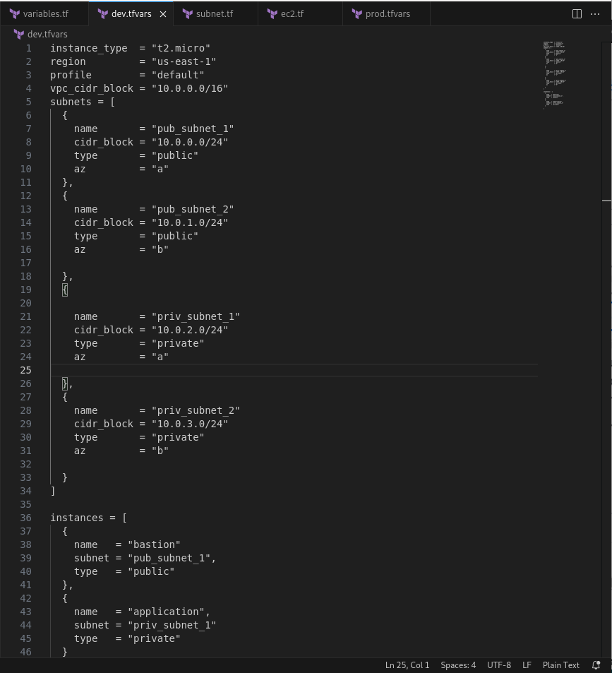

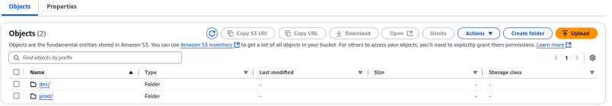
7-apply your code to create two environments one in us-east-1 and eu-central-1

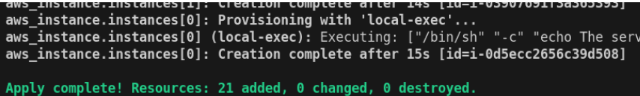
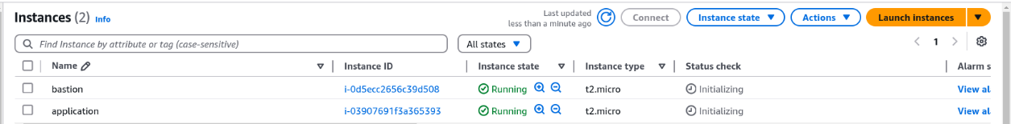

8-run local-exec provisioner to print the public_ip of bastion ec2

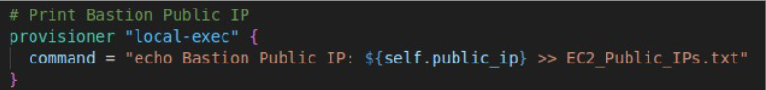
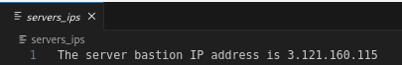

9- upload infrastructure code on github project
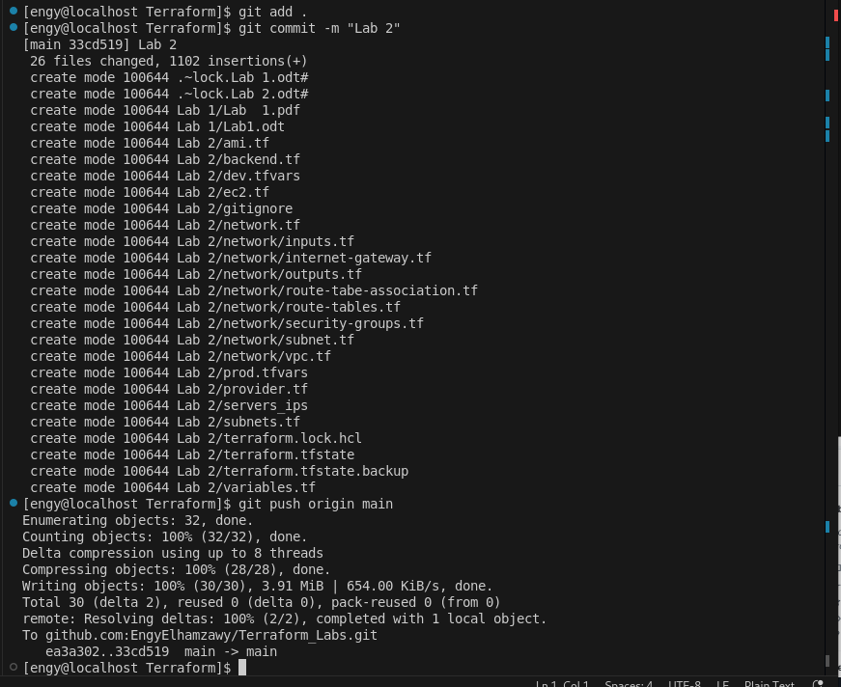

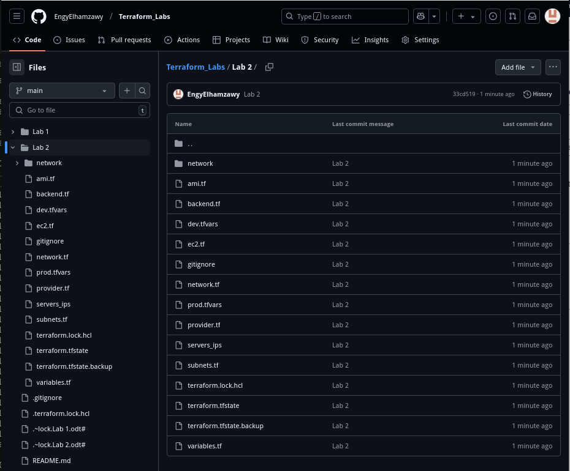
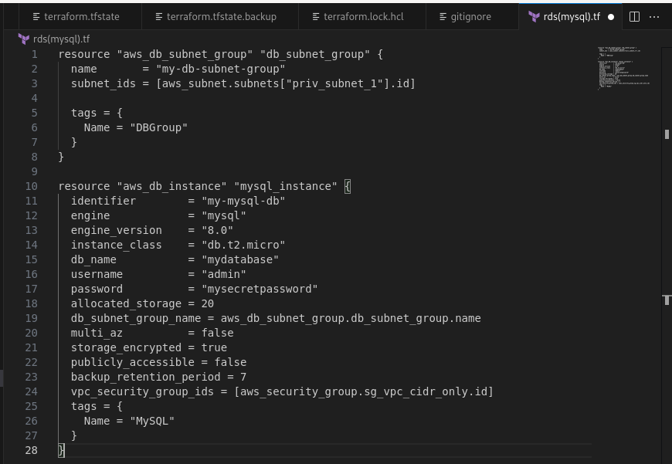
10- create rds(mysql) in private subnet

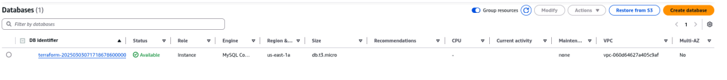

11- create elastic cache redis in private subnet
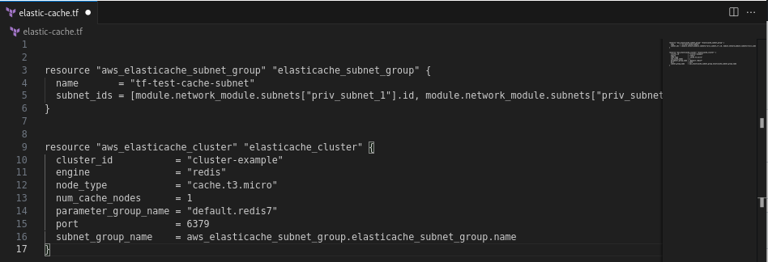
Finally , that’s all ! :)
You can access my github repo for this Lab through :
https://github.com/EngyElhamzawy/Terraform_Labs/tree/main/Lab%202

